Computer Networks Project 1

Name : Sai Aravind Palagummi Venkata Naga

UTA-ID: 1001242023

Simple WebServer and Client

1. Compile and execute using the following commnads as shown below

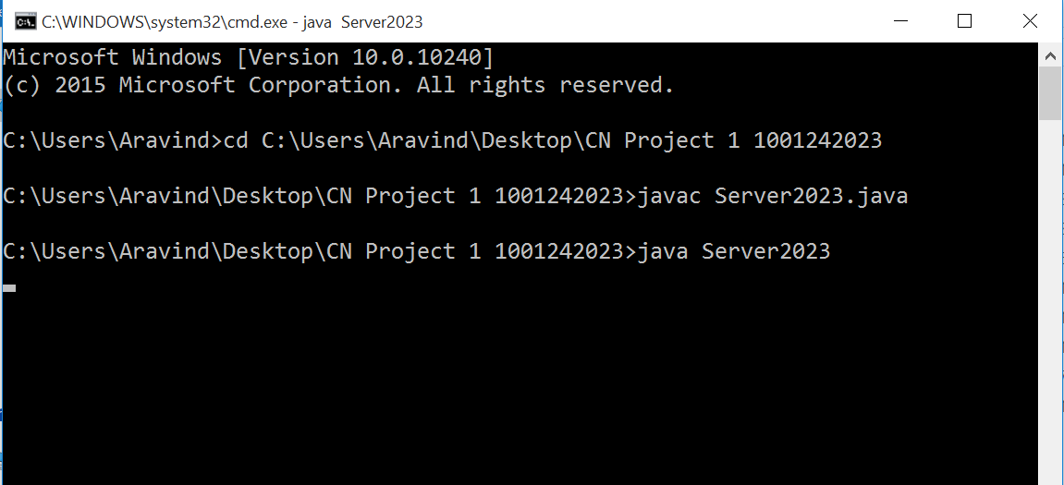

1. Compile the Client and enter the required data and run it as follows

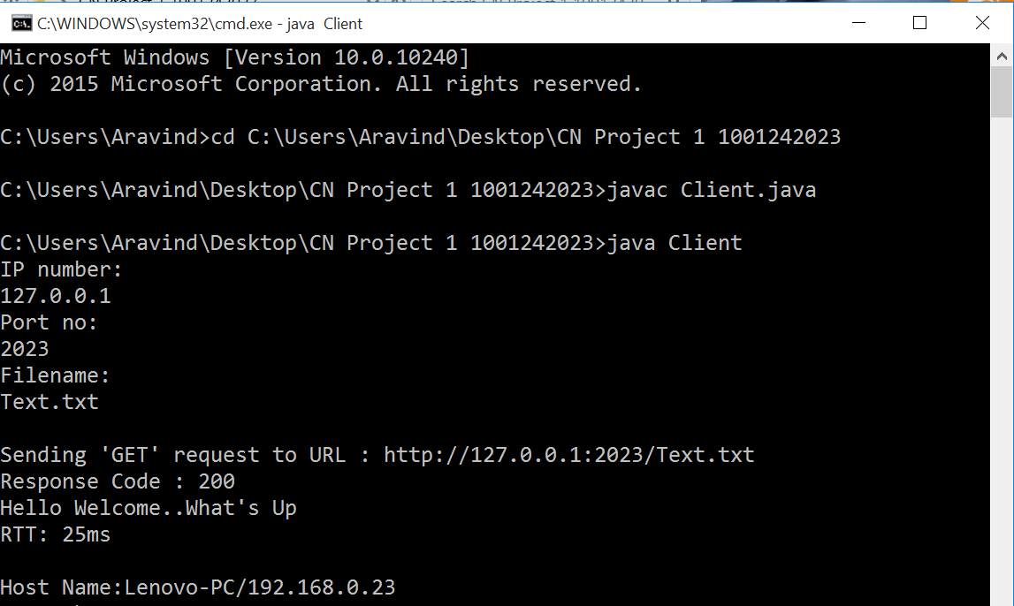

1. When file is requested in a browser

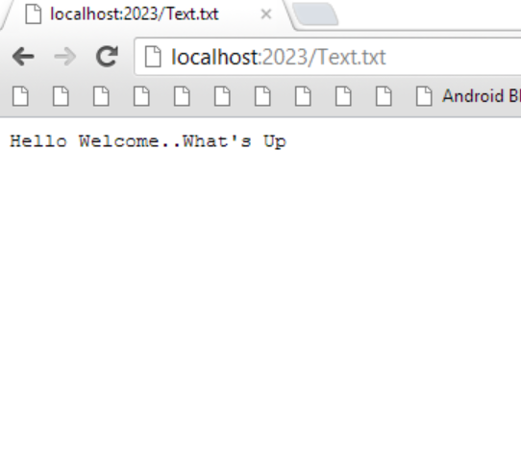

References and Citations

<http://www.ccs.neu.edu/home/rraj/Courses/U640/F04/Programs/WebServer.java>

<http://www.java2s.com/Code/Java/File-Input-Output/BufferedcopyingbetweensourceInputStreamReaderStringandbyteanddestinationsOutputStreamWriterStringandbyte.htm>

<https://www.youtube.com/watch?v=eRhxxFefAeA>

<https://www.youtube.com/watch?v=0mGmffH6CTs>

http://crystal.uta.edu/~datta/teaching/cse5344-4/Programming%20Assignment%201_reference_Java.pdf